**A Web Site: Talking Hands to Reduce Communication Gap with Hearing and Speech Impaired Persons.**

**8.1 Users of System:**

1. Normal peoples

2. Hearing and speaking impaired.

**8.2 Main page of website:**

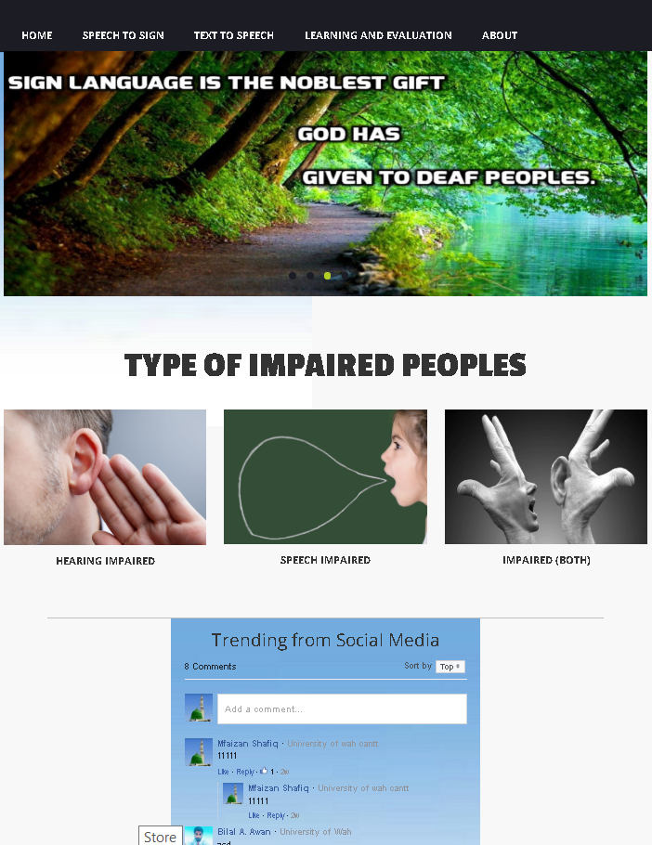

Section No.4 This image box has the detail of that type of peoples who can’t listen as well as speak

Section No.3 This image box has the detail of that type of peoples who can’t Speak.

Section No.2 This image box has the detail of that type of peoples who can’t listen

Section No.1 having links of different pages

Section No. 5

Social Media section

**Sec.1.1 Home:**

After the section 1 having all websites links we have following 3 sections which are**.**

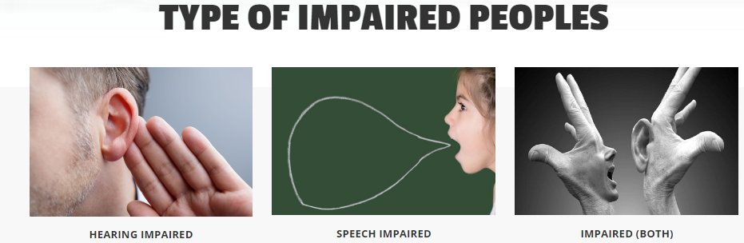

Section 4

Section 3

Section 2

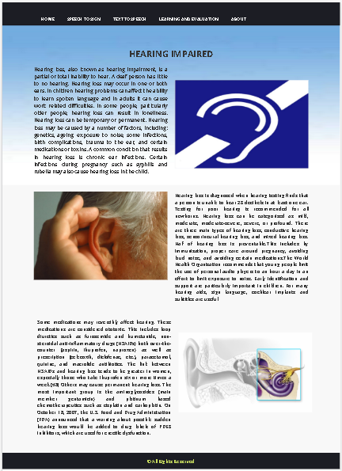**Section 2 (HEARING IMPAIRED)**

After clicking of user on this page a web page will appear having information about the peoples having week sensation of listening or impaired to listening completely.

Section 2.1 is the web page which will appear which is given.

**Section 3 (SPEECH IMPAIRED).**

After clicking of user on this page a web page will appear having information about the peoples having week sensation of speaking or impaired to speak completely

Section 2.2 is the web page which will appear is given.

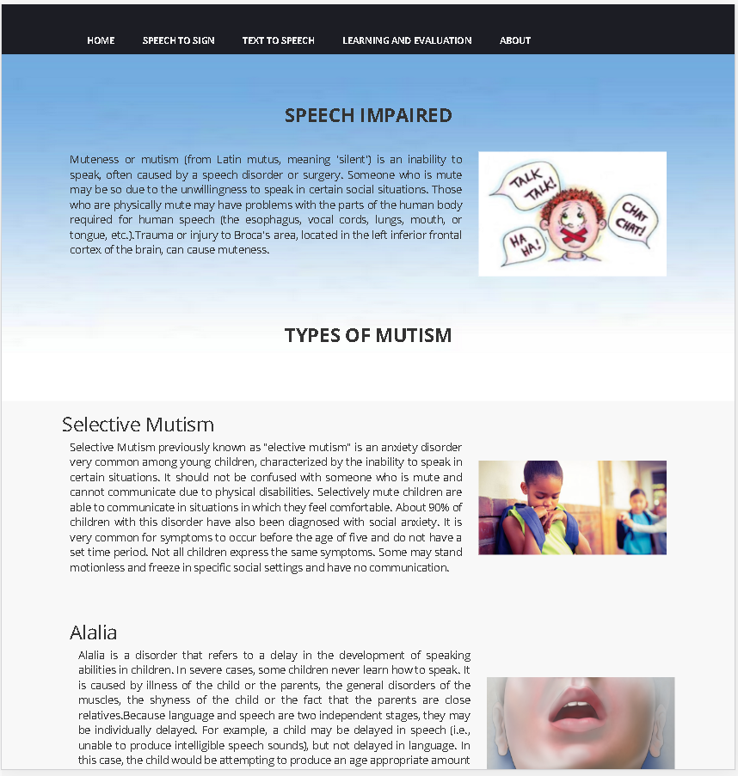**Section 4 (IMPAIRED BOTH).**

After clicking of user on this page a web page will appear having information about the peoples having week sensation of speaking and listening.

Section 2.2 is the web page which will appear is given.

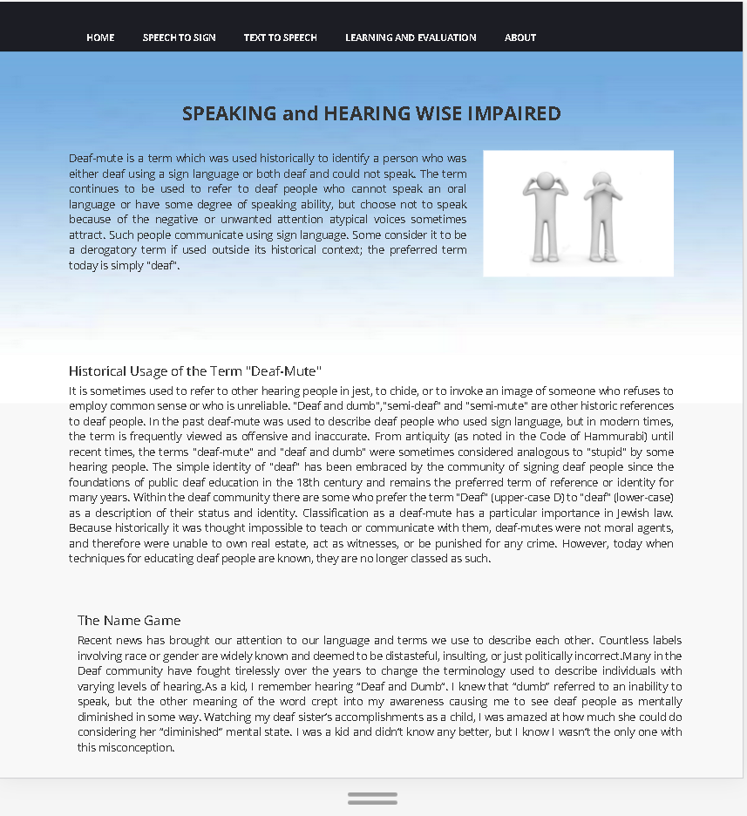

**Section 1.2(Speech to Text):**

After clicking this link tab the following web page will appear.

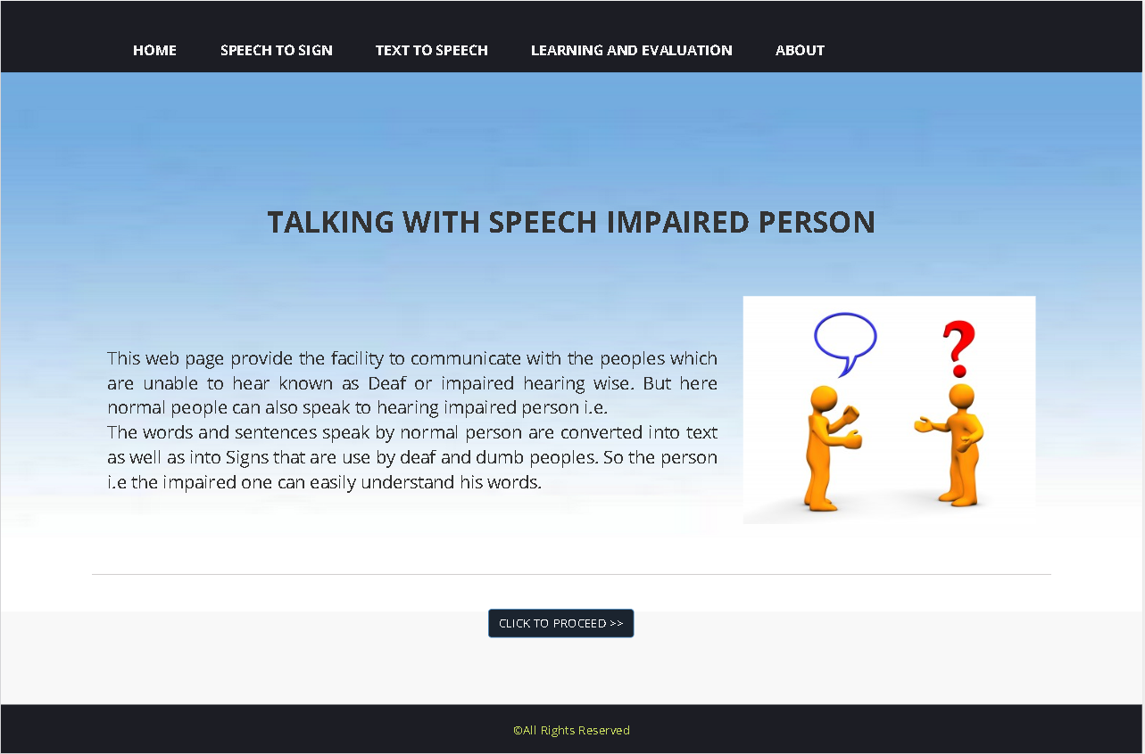

This button will provide Speech to sign web app.

**Section 1.2.1(WEB APP FOR COMMUNICATION):**

This page contain the following web app which will be used by normal user to communicate with peoples which are impaired hearing wise.

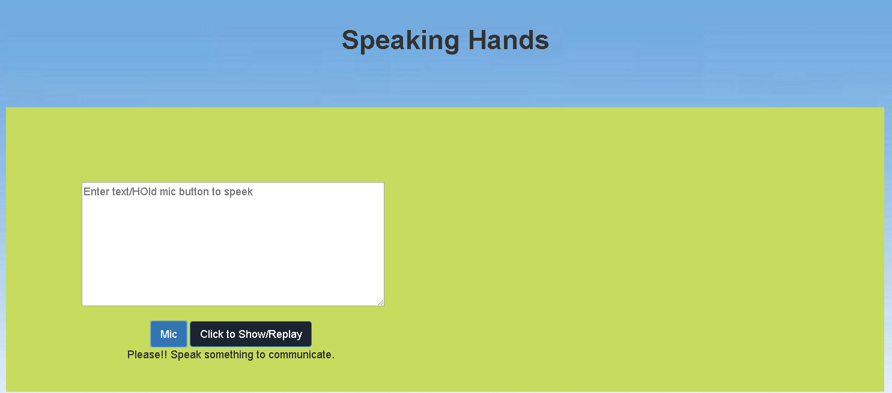

By clicking this button the speech recognition will stop.

By clicking this the app will start listening to the user (normal person)

This window shows extracted text from the user’s voice.

This window will show relevant sign so hearing impaired person can understand that what the normal person want to say.

**Section 1.3 (TEXT TO SPEECH):**

This page contain the web page having a web app for the speaking wise impaired persons who are unable to speak.so they type their respective words and app will speak out as it is.

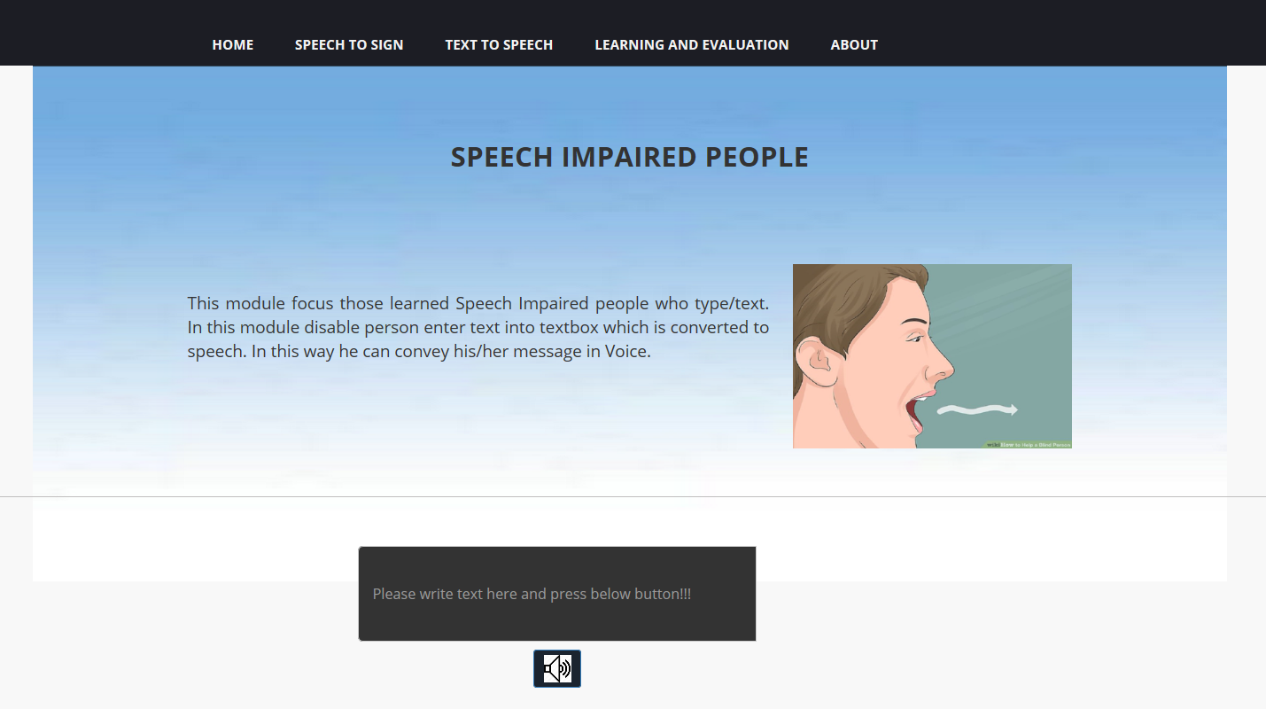

After entering text he/she have to click the button and app will convert the text into voice.

User (speaking) wise impaired person will type here.

**Section 1.4 (LEARNING AND EVALUATION):**

Before learning and evaluation link tab one have to go through the REGISTRATION and LOG-IN procedures so after clicking this tab following web page will appear.

**Section 1.4.1 (Registration):**

After clicking register link user following page will appear.

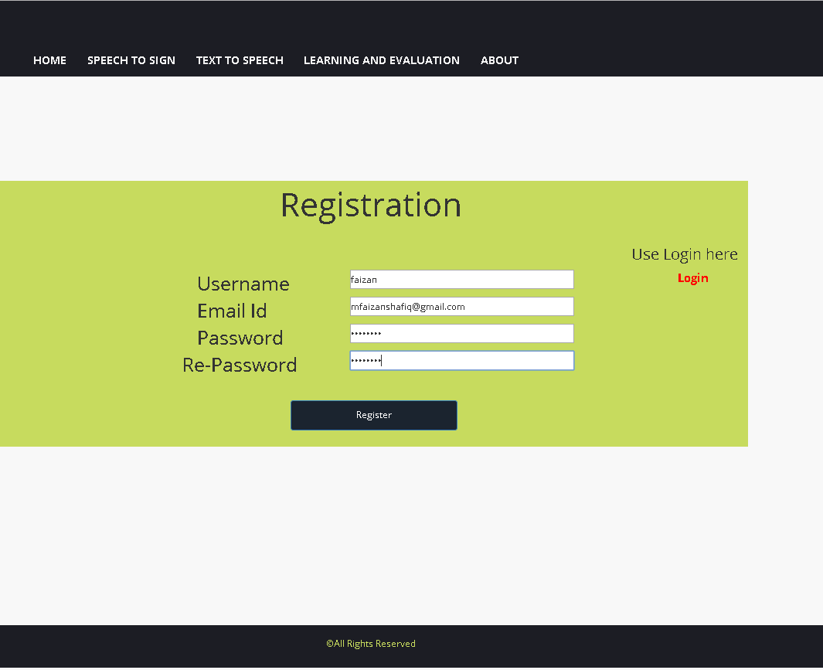

After filling the valid information click to register.

Enter valid email ID

For confirmation retype password

Enter user name which will be used for log in

Enter your respective password which will be use in future for login.

After click on Register button following confirmation popup will generate to conform registration.

After click on Register button following confirmation popup will generate to conform registration.

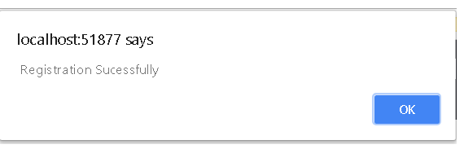

After this click on ok and then on login link.

**Section 1.4.2 (LOG-IN):**

Registered user will login here to access allowed options.

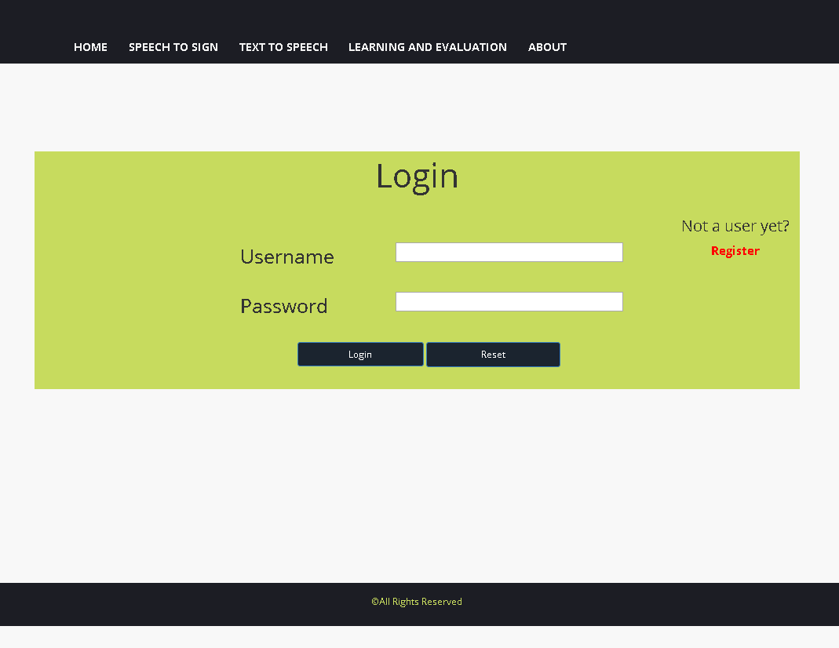

Click on this link for registration if you are not a registered user

Click this button to login after filling the above text fields.

Enter registered user name in this field

Enter your password

Click this button to reset the above text fields

**Section 1.4.2(after log in):**

**Following web page will appear.**

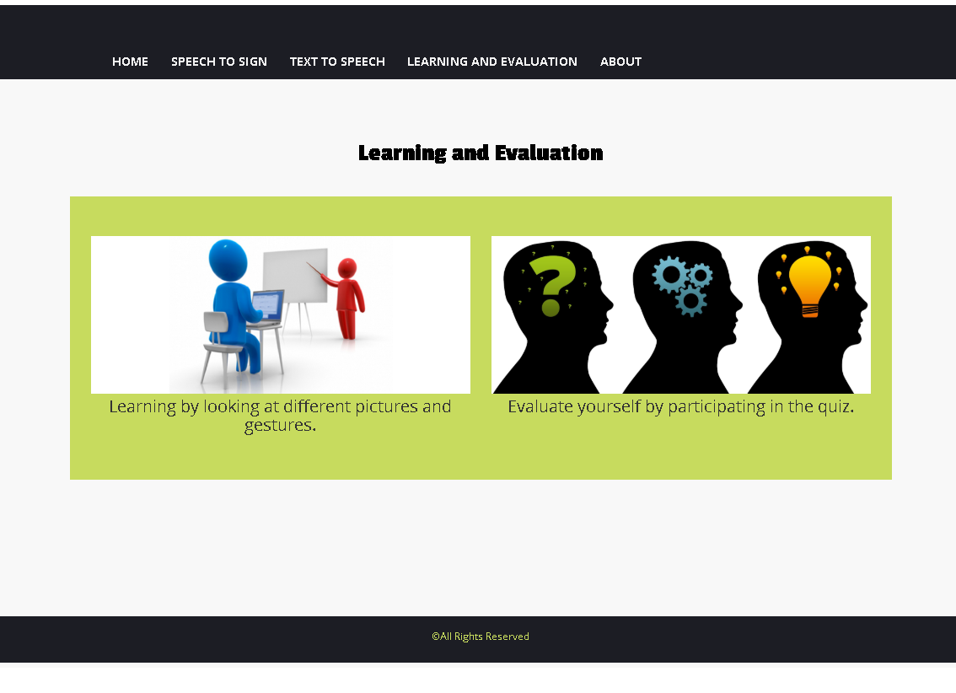

Section 1.4.2.2

For participating in Quiz

Section 1.4.2.1

For learning sign language

**Section 1.4.2(i) (Learning):**

This section is for the users who want to learn something e.g. by typing English words and learn the relevant meaning of that specific word.

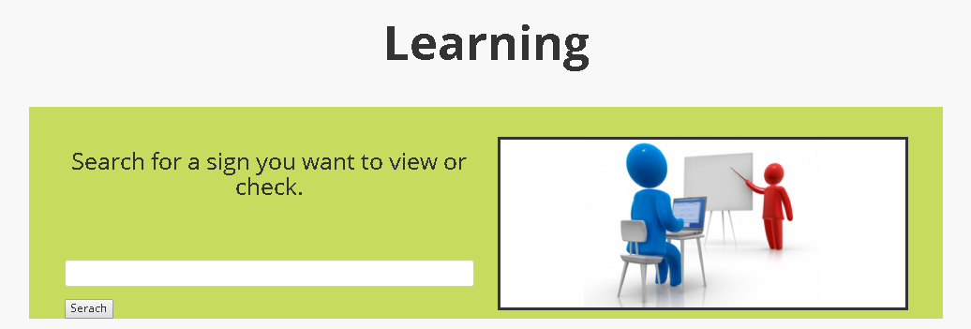

This field is use to enter text i.e. English words which you want to know

This window show the entered sign

Click this button to learn the sign

**Section 1.4.2(ii) (Contribution):**

This section is use for those user who want to contribute to our database by uploading sign relevant videos or pictures.

Here the user will see the uploaded image

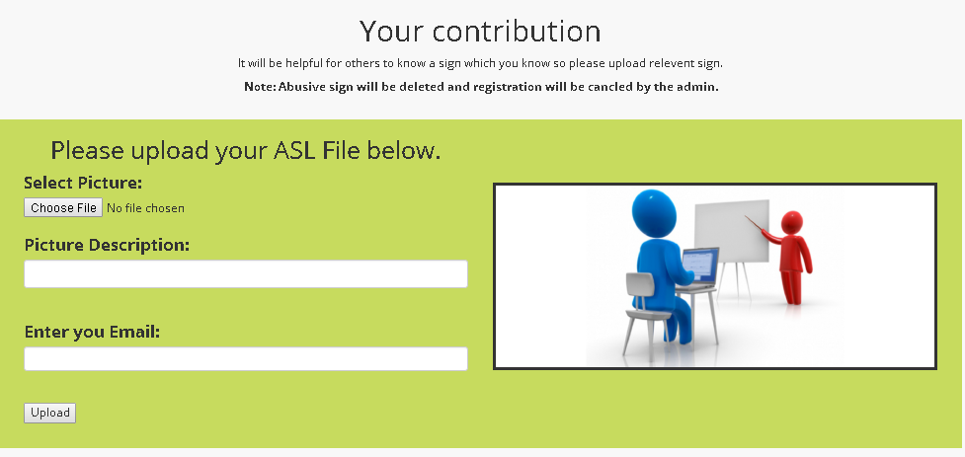

Only registered user can upload file so he/she have to enter email-id.

Click to select the file from your device

In this field user enter the description of his uploaded file.

**Section 1.4.2(iii) (manual learning slider):**



Click for next sign

Click for previous sign

**Section 1.4.2.2 For participating in Quiz:**



**Section 1.4.2.2(i) Sub Section:**

This web page will appear after the selection of one of the option provided to user i.e. selected option is “Evaluate Your Self By participating in Quiz”.

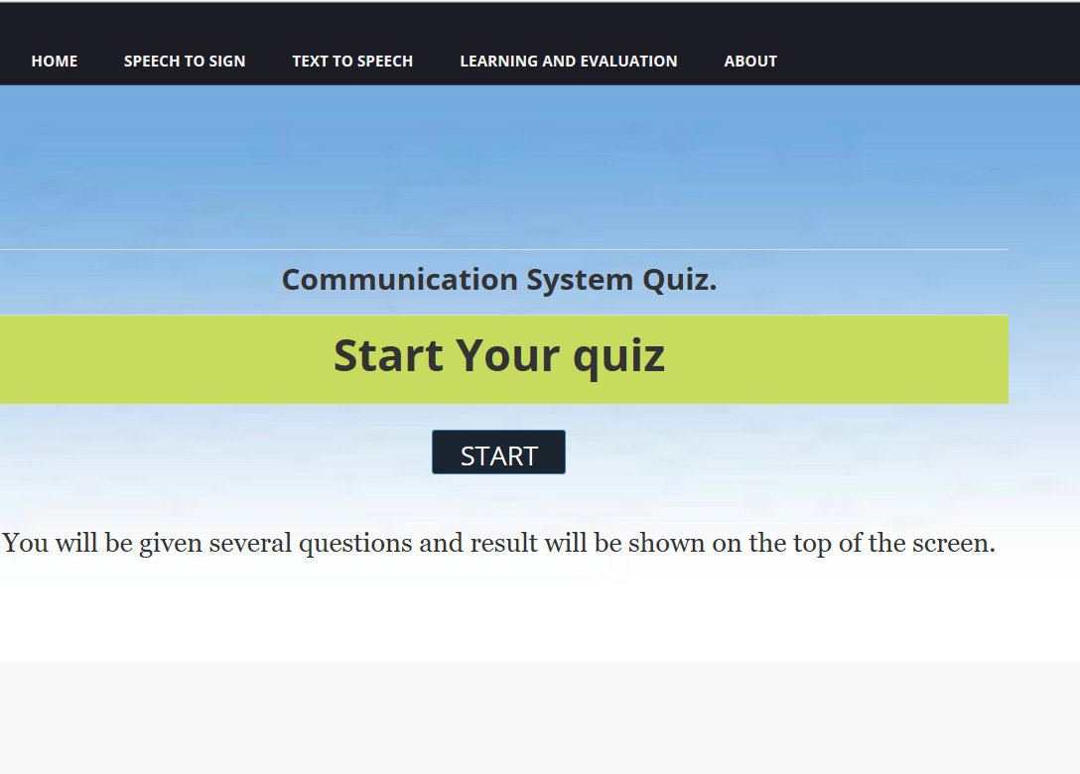

Clicking this button will start the quiz

**Section 1.4.2.2(ii) Sub Section:**

After clicking the button the following quiz web window will appear having multiple choice question this window provide quiz timer for users or participants and also user are evaluates according to their true or false options and score will be appear at the right corner of the window.

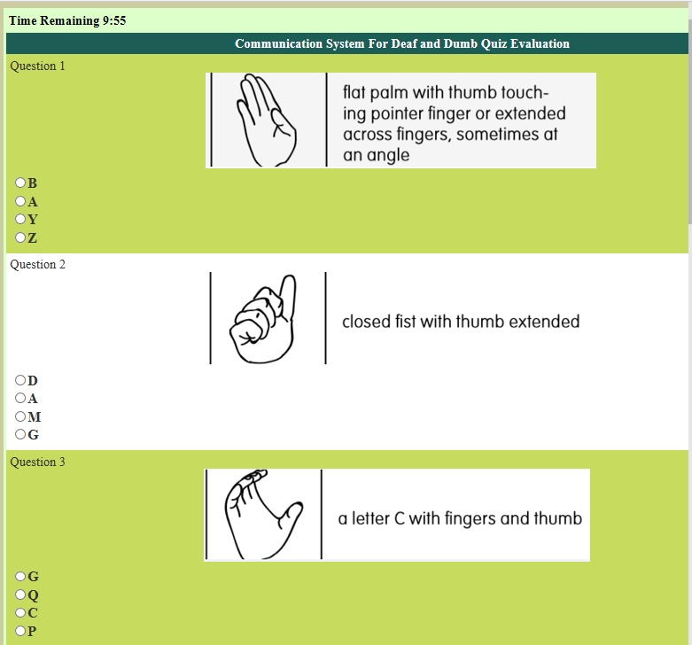

Quiz Timer

MCQ’s

Questions

**Section 1.4.2.2(iii) Sub Section:**

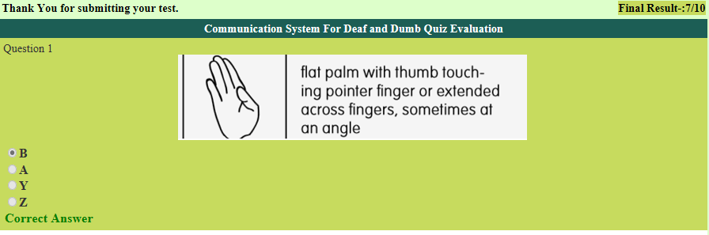

Total score after test